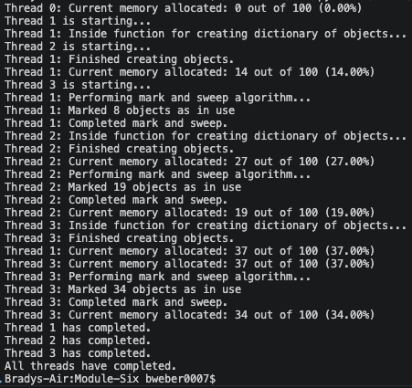
[program output]

The data structure that was used to simulate memory allocation and object lifecycles was a dictionary. The dictionary was initialized with 100 key-value pairs where the keys represented the memory addresses and the value represented both the allocation state and object lifecycle. The values were initialized to None in order to simulate empty or unallocated memory addresses. Then when each thread would create objects, it would only assign them to memory addresses (keys) that were unallocated (value of None).
In order to simulate the object’s lifecycle, a function was used to randomly assign a value of 0 or 1 to the objects in memory that contained objects. The binary values represented whether the object was in-use (1) or not in-use (0).
For the mark-and-sweep function, a list was used to hold any object that contained a value of 1 (in-use) as the function iterated over every memory address. Then, the sweep phase assigned a value of None to any memory address that was contained in the previously collected list in the mark phase in order to simulate the de-allocation of that memory address.
Any function that accessed the shared data structure, which simulated the heap, utilized a global threading.Lock variable and the “with” context manager to ensure that any access or manipulation was safely performed.
As shown in the screenshot above, the program outputs information regarding object creation, memory allocation, reclamation, and thread interactions. When the threads are started, finished, and all threads are finished, print statements are executed. Also, every other output statement is prepended with the thread_id number to easily identify which thread performed which actions. The number of objects that were created by each thread is output. At multiple points throughout the program and within each thread, the number of memory addresses and the percent of memory currently allocated are output. During the mark-and-sweep function, multiple output statements display the progress of the reclamation as well as the number of objects marked as in use during the mark phase.
The core challenges and solutions related to memory management that this program reflects include garbage collection and secure multithreading measurements with regards to shared data. When implementing multithreading and utilizing any global or shared mutable data structures, it is important to ensure that the threads are safe from creating race conditions that can endanger the data’s integrity. By implementing a primitive lock with the Python threading library, every attempt at accessing the global shared dictionary is protected from these race conditions. Many modern programming languages have built-in garbage collection. However, for those that don’t, concurrency can rapidly increase the amount of memory consumed by a program if not properly reclaimed. Even when concurrency is not in use, allowing programs to occupy memory without a need for it is a poor programming practice. The simple mark-and-sweep method implemented in this program demonstrates how proper memory management should minimize how much memory is allocated during runtime.

